Unit 4 HW 17 Name: __________________________________ Period: __________
For #1 and #2, circle the method you would choose to find the x-intercepts, and provide a brief explanation as to why you would choose that method.

- Equation: $x^{2}-7x+12$ Factor Complete the Square Quadratic Formula

- Equation: : $x^{2}+8x+19$ Factor Complete the Square Quadratic Formula

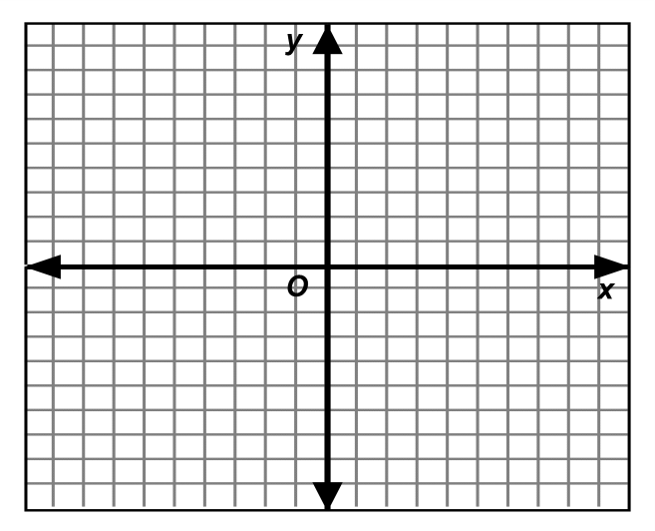
- Solve the system by graphing.

$$y=x^{2}+4x-5$$
$$y=3x+1$$

  - What is the vertex of the quadratic equation? ___________

  - How many solutions does this system have? 0, 1, or 2? ___________

  - What are the ordered pair solution(s) if they exist?

_____________________ and _______________________

- Mr. Sacco decides to try pole vaulting for the first time. He starts out jumping off a platform that is 2 feet high because it’s the first time he is trying to pole vault. His initial velocity is 8 feet per second.
$y=-16x^{2}+v_{o}x+c$
  - How long will it take for Mr. Sacco to reach the ground? Circle your answer.
(For the sake of this problem he clears the jump)

  - What is the maximum height he will reach? Circle your answer.

Perform the indicated operation.
- $\left(4x^{2}+9-3x\right)+(-15x+2x^{2}-7)$ 6. $\left(4x^{2}+9-3x\right)-(-15x+2x^{2}-7)$

- $(3x-5)(2x^{2}+6x-1)$

- Mrs. Ver Heecke feels that as the school year progresses she has to tell her students to “be quiet” more often. The first week of the semester she told her students to be quiet 24 times, the second week she told them to be quiet 36 times, and the third week she told them to be quiet 54 times.
  - Is this situation modeled best by an Arithmetic or Geometric equation? ______________________

  - Write an equation to model the situation. ___________________________________

  - How times will Mrs. Ver Heecke say “be quiet” the 9th week of school? Round appropriately.

