Unit 4 HW 15 Name: _________________________________________________

- Since she missed her flight to Acapulco and has to spend her break in the Quad Cities, Mrs. Pischke climbed to the top of a rock formation that sits 160 feet above the Mississippi River. In frustration, she launched her entire potato launcher off the cliff with an initial velocity of 48 feet per second. Use the quadratic equation that models projectile motion to answer the following questions.

$$y=-16x^{2}+v_{0}x+h_{0}$$

  - How much time will it take for the launcher to reach the water?

  - What is the launcher’s maximum height?

- Find the x-intercepts by completing the square.

$y=x^{2}-8x-56$

- What is $y=mx+b$ called (circle the correct answer)?

STANDARD FORM SLOPE-INTERCEPT FORM

  - What does the m represent in the equation?

  - What does the b represent in the equation?

  - Explain, in words, how you would graph the following equation $y=-\frac{3}{2}x+5$.
(Ex. First, you should……., and then from there you would…..)

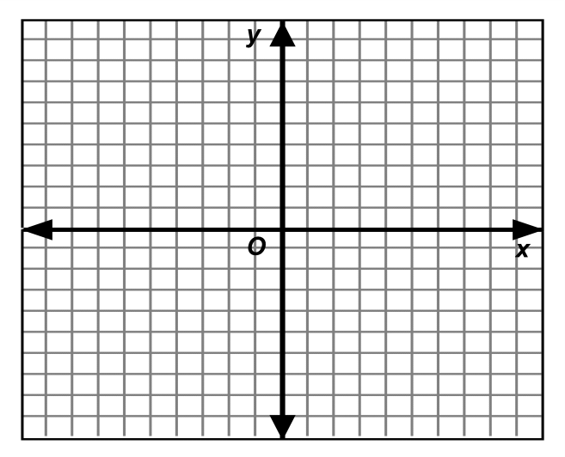
- Solve the system of equations by graphing.
$$\left\{\begin{matrix}5x+2y=-2 \\ 2x-y=10\end{matrix}\right.$$

- Use elimination or substitution to check your answer to #4.
$$\left\{\begin{matrix}5x+2y=-2 \\ 2x-y=10\end{matrix}\right.$$

