Unit 4 HW 14 Name: _________________________________________________
Find the vertex of each quadratic using either method. Now find the x-intercepts.
- 1. $y=x^{2}-2x-6$ | - $y=x^{2}-2x-6$

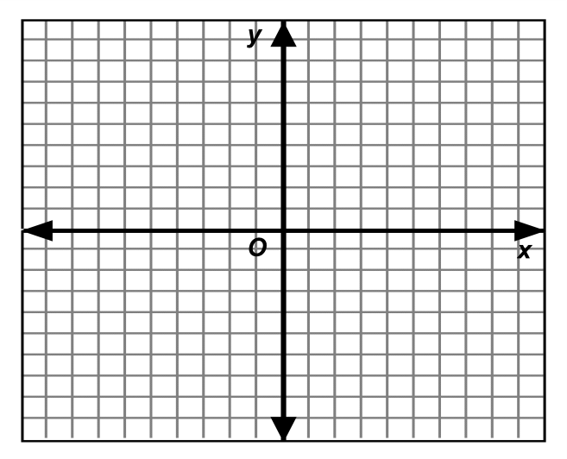
- Graph your answers from #1 and #2.

- Complete the Square to put the equation in vertex form: 5. Find the x-intercepts: $y=x^{2}+10x-56$
$y=x^{2}+10x-56$

- Factor: $y=2x^{2}-22x+36$ 7. Find the x-intercepts: $y=2x^{2}-22x+36$

- Factor: $y=3x^{2}-4x-4$ 9. Find the x-intercepts: $y=3x^{2}-4x-4$

- Mrs. Pischke was so sick of grading her homework assignments that she went to the top of the nearest cliff and threw her stack into the river. The following equation represents this situation:
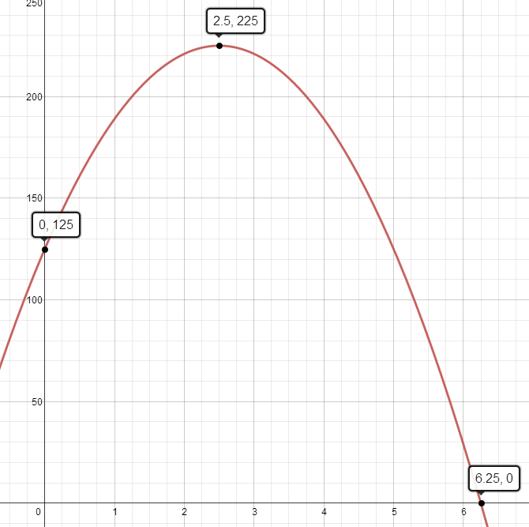
$$h=-16x^{2}+80x+125$$
- What is the height of the cliff?

- Where is your answer to part “a” located on the graph?

- What does the ordered pair (6.25, 0) mean in
this situation? Explain using a sentence.

- What does the ordered pair (2.5, 225) mean in
this situation? Explain using a sentence.

- What is the height of the papers after 4 seconds?
Show your work.

- $(2x^{2}-7x+3)(3x^{2}-4)$

