Unit 4 HW 13 Name: _________________________________________________
Solve to find the x-intercepts by factoring.
- $y=x^{2}+10x+21$ 2. $y=3x^{2}-33x+72$ 3. $y=2x^{2}-7x-22$

x-intercepts: _________________
x-intercepts: _________________
x-intercepts: _________________

Solve to find the EXACT x-intercepts by completing the square and identify the vertex.
4. $y=x^{2}-6x+7$ 5. $y=x^{2}+12x+18$

x-intercepts: _________________
vertex: _____________________
x-intercepts: _________________
vertex: _____________________

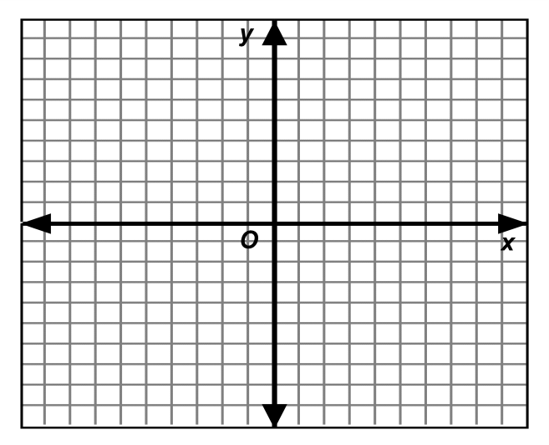
- Solve the system of equations using any method
(substitution, elimination, or graphing).
$$\left\{\begin{matrix}y=2x+5 \\ 3x+2y=-4\end{matrix}\right.$$

Find the APPROXIMATE x-intercepts of each quadratic using either by factoring or completing the square.
- $y=x^{2}-18x-88$ | - $y=x^{2}+8x-44$

- Circle the method that you used for question “7” (above): Factoring Completing the Square
Explain: Why would you choose this method for this particular question?
--------------------------------------------------------------------------------------------------------------------------------------------------------------------------------------------------------------------------------------------------------------------------------------------------------------------------------
- Circle the method that you used for question” 8” (above): Factoring Completing the Square
Explain: Why would you choose this method for this particular question?
--------------------------------------------------------------------------------------------------------------------------------------------------------------------------------------------------------------------------------------------------------------------------------------------------------------------------------

