The following data is from a recent Geometry Quiz scored out of 25 points. Find the mean, median, mode, range, standard deviation, and draw a box a whisker plot for the data.

20, 21, 22, 24, 22, 19, 23, 19, 19

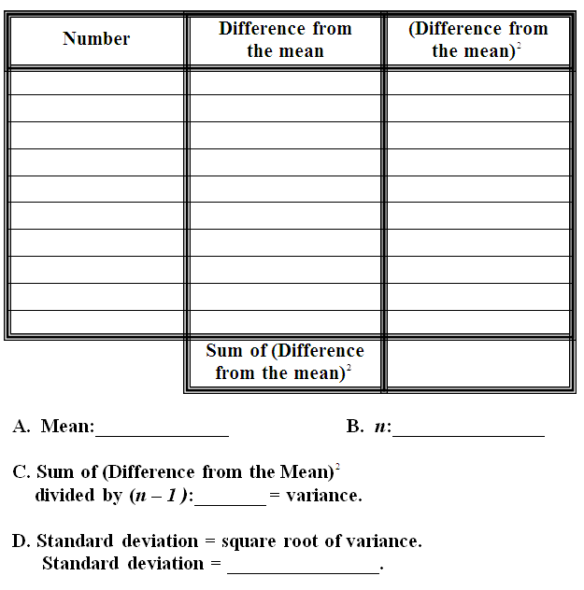

Mean
Median
Mode
Range
S-Dev

See how adding one data point can drastically affect the outcome of the statistics. Find the mean, median, mode, range, standard deviation, and draw a box a whisker plot for the data.
.
20, 21, 22, 24, 22, 19, 23, 19, 19, 6
New Data Point

Mean
Median
Mode
Range
S-Dev

