Two Way Frequency Table – Allows us to organize and visualize our data so we can determine probabilities

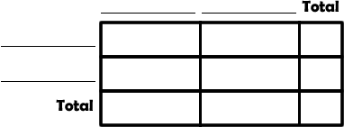
Have a pet:
No pet:
Have a pet and prefer comedies:
Have a pet and prefer horror:
No pet and prefer comedies:
No pet and prefer horror:

In band:
Not in band:
In band and in chorus:
In band and not in chorus:
Not in band and in chorus:
Not in band and not in chorus:

Independent – The first action does not affect the second action
Complete each two way frequency table below

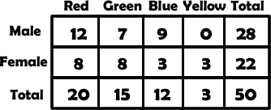
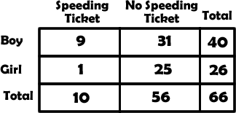

Create your own scenario:

________________ vs. __________________ and ________________ vs. __________________

Poll the class:

Create your two way frequency table:

Follow-up questions:
- Do you think your two relationships are independent, why or why not?

- What are some ways we could use this table?

