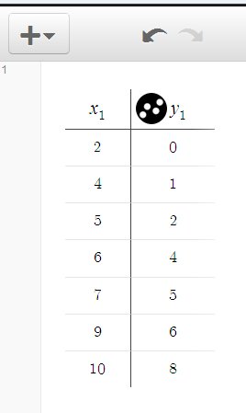
- Visit desmos.com and launch the online calculator.

- Add a “Table” by clicking on the

- Insert your data into the table for $x_{1}$ and $y_{1}$as seen in $"Figure 1A."$
$$Figure 1A$$
- Add a new “expression” by clicking on the

- Enter the linear equation $y_{1} \sim mx_{1}+b$
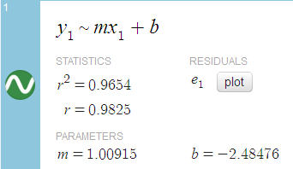
Be sure to use the subscript given on the keyboard to type $x_{1}$ and $y_{1}.$

- Desmos will recognize the line of best fit for the data in the table you entered and give you the correct equation and correlation coefficient as seen in $"Figure 2B."$
$$Figure 2B$$
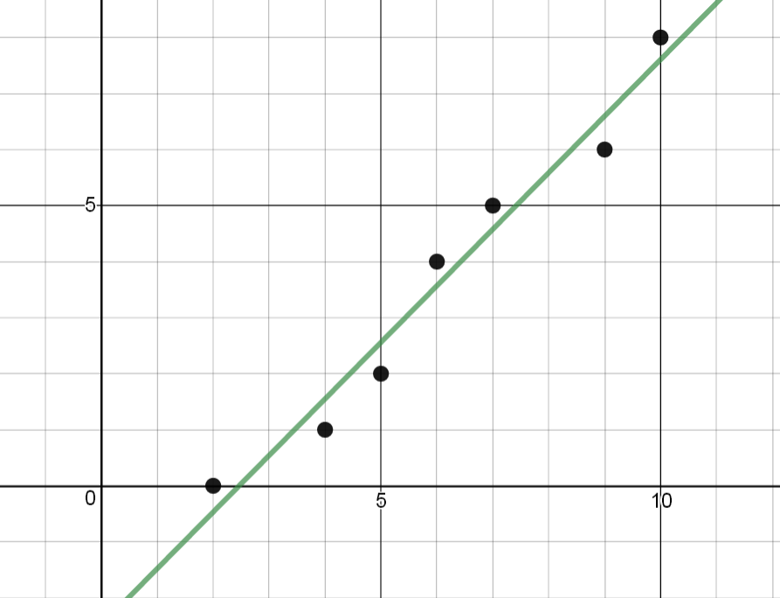
$$Figure 3C$$

