Median & Quartiles
Remember:
Median: Middle number (when data is in order)
Lower Quartile: The median of the lower half
Upper Quartile: The median of the upper half

1. Percentage achieved in a Statistics test:
78 82 74 45 68 75 93 54 61 70 48 66 62 51 77

Median: Lower Quartile: Upper Quartile:

2. Minutes per day spent playing computer games:
40 26 60 64 33 39 28 46 47 51 55

Median: Lower Quartile: Upper Quartile:

3. Time taken (in minutes) to solve a crossword puzzle:
12 24 21 16 8 9 3 31 18 27 35 41 26 12 17 6 5 19 29

Median: Lower Quartile: Upper Quartile:

4. Weight in kg of year 10 boys:
47 51 63 39 42 57 36 37 49 32 60 54 56 45 52

Median: Lower Quartile: Upper Quartile:

5. Height in cm of a group of year 10 girls:
153 147 160 146 162 158 159 149 152 150 163

Median: Lower Quartile: Upper Quartile:

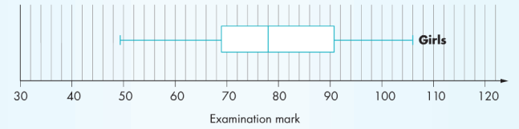
Box Plots
Upper quartile
Median
Lower quartile
Max. value
Min. value
1. Draw a box plot for the percentage achieved in the
statistics test.
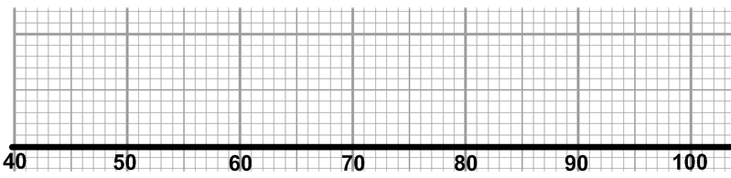

2. Draw a box plot for the minutes per day spent playing computer games.
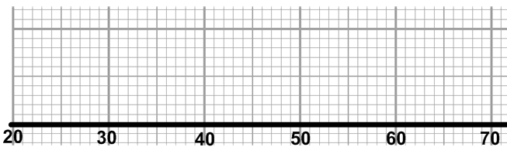

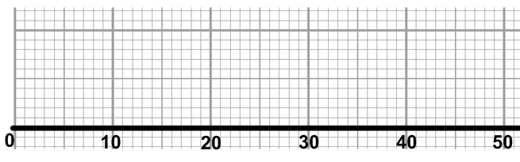
3. Draw a box plot for the time taken (in minutes) to solve a crossword puzzle.

4. Draw a box plot for the weight in kg of year 10 boys.
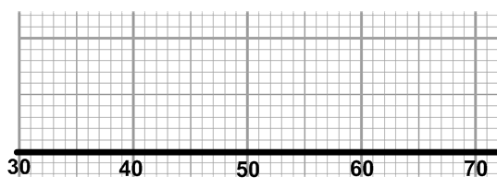

5. Draw a box plot for the height in cm of a group of year 10 girls.
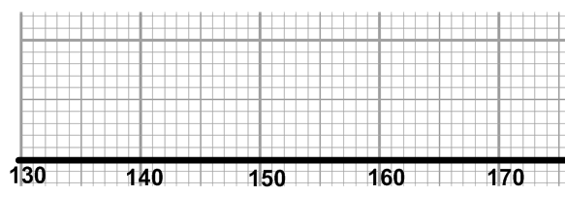

Median & Quartiles ANSWERS
Remember:
Median: Middle number (when data is in order)
Lower Quartile: Halfway between lowest number and median
Upper Quartile: Halfway between median and highest number

1. Percentage achieved in a Statistics test:
78 82 74 45 68 75 93 54 61 70 48 66 62 51 77
45 48 51 54 61 62 66 68 70 74 75 77 78 82 93
Median: 68 Lower Quartile: 54 Upper Quartile: 77

2. Minutes per day spent playing computer games:
40 26 60 64 33 39 28 46 47 51 55
26 28 33 39 40 46 47 51 55 60 64
Median: 46 Lower Quartile: 33 Upper Quartile: 55

3. Time taken (in minutes) to solve a crossword puzzle:
12 24 21 16 8 9 3 31 18 27 35 41 26 12 17 6 5 19 29
3 5 6 8 9 12 12 16 17 18 19 21 24 26 27 29 31 35 41
Median: 18 Lower Quartile: 9 Upper Quartile: 27

4. Weight in kg of year 10 boys:
47 51 63 39 42 57 36 37 49 32 60 54 56 45 52
32 36 37 39 42 45 47 49 51 52 54 56 57 60 63
Median: 49 Lower Quartile: 39 Upper Quartile: 56

5. Height in cm of a group of year 10 girls:
153 147 160 146 162 158 159 149 152 150 163
146 147 149 150 152 153 158 159 160 162 163
Median: 153 Lower Quartile: 149 Upper Quartile: 160

Box Plots ANSWERS
1. Draw a box plot for the percentage achieved in the
statistics test.

2. Draw a box plot for the minutes per day spent playing computer games.

3. Draw a box plot for the time taken (in minutes) to solve a crossword puzzle.

4. Draw a box plot for the weight in kg of year 10 boys.

5. Draw a box plot for the height in cm of a group of year 10 girls.

